Version 1
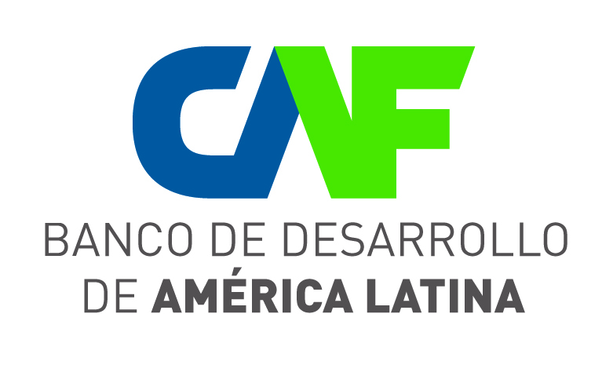
Vice-presidency for Development Strategies and Public Policy

Direction of the Environment and Climate Change (DECC)

ENVIRONMENTAL AND SOCIAL REPORT (ESR)
INFRASTRUCTURE, SOCIAL AND ENVIRONMENTAL DEVELOPMENT OPERATIONS
Operation Name | Construction of the Pica Solar Project Phase II. Atacama
Country | Chile
Assessment Date | November 2015
Person responsible and operation business area | Pedro Berroterán, VSPF
Executive / Assessment Consultant | José A. Blanco
Direction of the Environment and Climate Change (DECC) – Executive Responsible | José A. Blanco
Coordinator UGAI - DECC |  | Edgar Salas
 |  |  | Signature

EXECUTIVE SUMMARY
This project involves the construction, operation and maintenance of a 143MW photovoltaic park, located at a 75km distance from Iquique, capital city of the Tarapacá region in northern Chile, and at a 10km distance from the Pica and Matilla towns.

Two components are included in the project:
- The Second (143MW) phase of a larger-scale Photovoltaic Plant project (up to 250 MW);
- A 43km long transmission line, connecting the plant with the (fully operational) Lagunas Substation.
The project is located in the Atacama Desert, one of the areas showing the highest solar irradiation levels in Latin America and the world.
Bearing in mind this solar irradiation, Suntech Power-type panels, with a horizontal axis only, and SMA Solar inverters are being considered since, according to the manufacturers guarantee, they have a 25 year service life.
A Greek company with extensive experience in the sector – Biosar Chile SpA - has been awarded the project construction. In turn, the solar complex energy “output” shall be through a transmission line connected to the Norte Grande Interconnected System of Chile (SING). This transmission line shall be built and operated by the Transelec company, the largest electricity transmission company in Chile. Both companies shall be hired by Sonnedix Power Holdings Ltd.: the Client and applicant to the CAF Loan being referred to in this Assessment.
The main benefit this Project provides is the fact that, pursuant to the Chilean institutional and regulatory framework, the Electricity Transmission Expansion Plan is being buttressed. This Plan envisages the construction of two main transmission lines; one line to strengthen up the Central Interconnected System (SIC), and the second one to interconnect the SIC with the SING, resulting in a decrease in national power network congestion instances. The project has a positive impact on the Plan as it shows the feasibility for energy to be generated in such remote areas which, until now, had been deemed as an impossible endeavour. Moreover, the project shall be underpinning the renewable energies share in the electricity supply which, in this expansion plan is envisaging that, by 2025, twenty per cent of energy sales in Chile shall be originating in non-conventional renewable sources (ERNC), with the usual reduction of greenhouse gas (GHG) emissions from electricity production.
In environmental terms, projects of this kind are aimed at CAF objectives, environmental and social safeguards, and environmental strategy, since the fact that a country showing one of the highest per capita electricity consumption rates in South America is basing its electricity production on green sources, becomes into a green business source for CAF, besides being environmentally friendly.
Scant rain is usually recorded in the Project site over the summer season: December – March: about 30mm per year, with virtually no vegetation (only shrubs clusters and small-size trees, oasis type, supporting populations who are dependent of them), and absolutely no surface water bodies nearby, except for paleo channels and intermittent streams, with long return periods. This is the reason why the fauna present in the area is the typical Chile desert fauna: scarce, both in quantity and variety. In fact, surveys conducted by the Project proponent could only confirm the existence of five species (one reptile species, three bird species and one and mammal species) However, two of them are protected species, one is a vulnerable species: Microlophus atacamensis (reptile), and another is little and inadequately known: Lycalopex culpaeus (mammal), both of them found along the power transmission line.
Notwithstanding, and bearing in mind the mobility and adaptability of protected species, an estimation has been made that the project does not entail large environmental and social risks and impacts.
The power transmission line running from the project site up to the Lagunas Lift Station (LS) goes across the "Pampa del Tamarugal" Natural Reserve, a fact the Environmental Authority is duly aware of, and has further expressed its positive opinion about this. The fact that the same transmission line passes nearby -but causing no negative impacts whatsoever- and outside the perimeter of the area created to protect the Pintados geoglyphs, near the Pozo Almonte town, is a not so serious -but still important- matter. As a final consideration vis-à-vis protected areas, mention should be made of the fact that although the project area is NOT an indigenous area, according to the Client´s own perusal of surveys conducted, people who call themselves Indigenous Populations live in the Pica and Matilla towns and, therefore, in the Client´s Environmental and Social Management Plan, measures are being envisaged to address this fact.
CRITICAL ISSUES
Particular mention should be made of the fact that Sonnedix, the Client, has approached CAF, in its capacity as the Green Climate Fund (GCF) representative, and under the leadership of the Direction of the Environment and Climate Change, submits this Operation to secure the Fund financing. The Chilean government has already been approached with a request for Chile to grant the technical and governmental endorsement allowing CAF to continue negotiations with the GCF, arrangements which have already been endorsed by the GCF Official who would be in charge of this application for funding.
The project is being deemed as feasible from an environmental and social stance, bearing in mind the quality of environmental and social surveys the Client has already conducted, and bearing in mind the outputs which, to ensure the project viability, have already been developed and are currently undergoing their improvement process.
Notwithstanding the foregoing, the Client shall abide by CAF Environmental and Social Safeguards, the Chilean environmental regulations in force, and the following Special Environmental and Social -Conditions which the Client declares to be aware of:
Before the start of each work:
- The relevant Environmental Authorization applicable under current Chilean legislation (Environmental Certification Resolution (ECR), Environmental Impact Statement (EIS) Relevance Letter, etc.)
Over the disbursement period:
Submission of documents to CAF satisfaction:
- The Environmental and Social Management Plan (ESMP), with scheduled times adjusted to the actual Project work times, including at least components as follows: Budget, Community Communication Plan, Jobsite Signalling Plan, Contingencies Care Plan, and specific archaeological matters-focused measures, health and safety at work, and any other matters as may have been approved project-wise. These requirements should be duly abode by over the forty-five (45) days following the first disbursement.
- Environmental surveys and permits for any new work as required, or a report showing that such authorization is not required.
- Quarterly progress reports (January-March, April-June, July-September, and October-December) including the Project´s own physical and financial progress (budget execution) of environmental and social issues. No later than thirty (30) days after the quarter concerned has expired.
- Submitting Special Reports at all times follow-up inspections are being performed by CAF, and at any time as CAF may request, bearing in mind the scope and formats as timely set down by CAF.
- Once the project execution is over, submitting the closing report, not later than one hundred and twenty (120) days have elapsed after the date of the last disbursement, and pursuant to the terms as set down by CAF.
- Whenever a significant change becomes apparent in the project, or in the natural or social setting where the project is being executed, likely generating new environmental and social impacts not foreseen in the assessment originally conducted by CAF, or likely maximising existing impacts, they should be reported to CAF for the latter´s prior assessment and compliance.
- Specifically, if an additional activity or project is executed within the "Pampa del Tamarugal” Nature Reserve, the IV Safeguard stating "...pursuant to the relevant legislation in force in the country where this operation is being executed, projects in protected areas are funded to the extent that the operation shall contribute to the compliance of objectives for which the protected area in question has been created..." shall be applied as a precautionary principle.

- Description of the Operation
The Sonnedix company´s Atacama Solar Project involves the construction, operation and maintenance of a 143MW photovoltaic park.
This project is located in the Atacama Desert, at some 75km from Iquique (about 120km by road), the capital city of the Tarapacá region, and only 10km from the Pica and Matilla towns, in the northern Chile region: one of the areas with the highest solar radiation range in Latin America, and within the largest in the world: about 3.35 KWh / m2.
This is the reason behind the decision to using Suntech Power type panels, with only one horizontal axis and SMA Solar inverters which, according to manufacturers, guarantee a 25 year service lifespan.
This project is intended to be developed over a 1,000ha area under Onerous Use Concession (OUC) by the Chilean Ministry of National Assets (MNA), which, pursuant to Resolution No. 1182 of 10 October 2013, has been granted permits for development and transmission of Non-Conventional Renewable Energy over a 30-year period.
Sonnedix is planning to build and operate a 250MW photovoltaic plant over three phases:
Phase I (pilot) = 0.5MW (In Operation)
Phase II = 142.5MW (Current Project)
Phase III = 107MW (Future Development)
The project shall be integrated into the Chilean electric system consisting of four blocks: The Norte Grande Integrated System (NGIS), the Aysen and Magallanes Central Interconnected System (SIC). Ninety-nine per cent of electricity production in the country is concentrated in the first two blocks, i.e., in the North Central region of the country.
Notwithstanding how consolidated the Chilean electricity system is, the country is usually facing problems at the time of interconnecting each of these blocks or systems, a situation leading to price differences, depending on the block in which problems become apparent, and the block where the electricity gets into the system.
The responsible entity seeks to address this problem by (i) the interconnection of the Central Interconnected System (SIC) and the Northern Grand Interconnected System (NGIS), and (ii) strengthening up the SIC itself, all the above before 2019. This is the interconnection the regulatory body is interested in because of the greatest rationale it adds to the Project.
Still another justification, more directly related to the CAF Direction of the Environment and Climate Change work, is that the Government of Chile aims that by 2025 the share of renewable energies in the electricity supply is at least 20% of the energy being sold from non-conventional renewable sources.
In this sense and to bringing forward the date for construction of Stage III to get under way, thus getting in place a 250MW Photovoltaic Power Plant, the Sonnedix company, through CAF, is submitting this project to the Green Climate Fund (GCF) to lowering the funding price. CAF, as a GCF implementing agency, has contacted the officer in charge of evaluating the project and, over initial discussions the Fund has stated its willingness to get involved. The only step still to be completed is the endorsement to be granted by the Chilean government through its Focal Point.
Project subcomponents are:
- Photovoltaic park implementation-associated works: through entering into an Engineering, Procurement and Construction (EPC) contractual agreement with the BioSAR Chile SpA company;
- Transmission system-linked works: Through a a (Build, Operate, Own and Transfer (BOOT) contractual agreement: with Transelec, perhaps the most experienced company in Chile in construction of transmission lines and substations. These works are also subdivided into:
- Lift substation
- Transmission Line 1 x 220 kV Atacama Solar – Laguna
- Works required at the Laguna Substation for energy supply to the market via SING
The map below (Figure No. 1) shows the Project location vis-à-vis Iquique, Pica / Matilla and surrounding areas.
Figure 1. Location of the Pica Solar Project. Atacama Desert, Chile
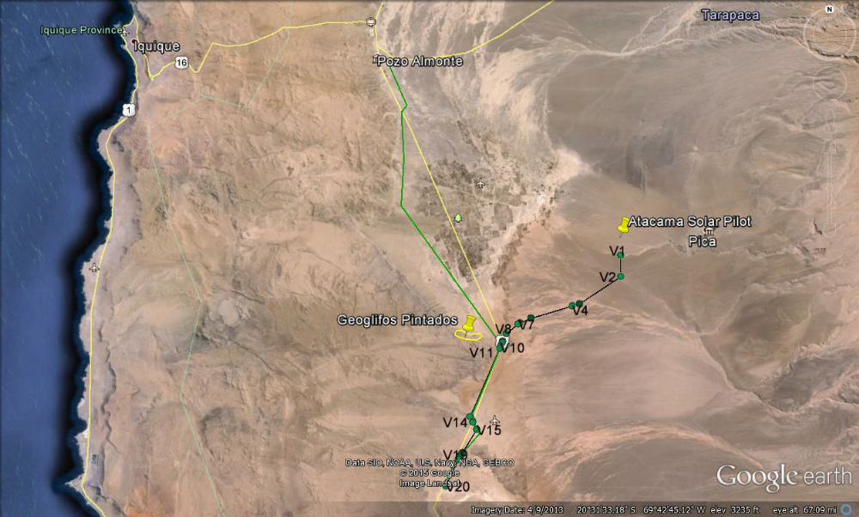
Source: Sonnedix. Environmental and Social Impact Assessment Summary

II. Description of environmental and social characteristics
All sites in which Project-related works are scheduled to be executed and surrounding towns were visited over the evaluation mission. All of them are located in one of the driest and deserted places in the world: the Atacama Desert, Chile. A fact making us believe that, as shown by environmental surveys being conducted by the Client, there will only be few, low-intensity, easy to monitoring and keeping in check impacts. Even the everyday life during the execution of works seems to be a major risk, as sites, with the exception of the transmission line close to a road, are truly isolated. Concerning the transmission line, the involvement of the road traffic, bearing the volume of traffic in mind, also seems to be very mild, although particular care should be taken.
Most relevant environmental and social features are referred to below to backing up the paragraph above.
Climate: As mentioned above, the Atacama Desert is one of the driest areas in the world, hosting locations with less than 1mm average rainfall per year. In the particular case we are referring to, the Pica-Matilla area is known as "pampa" because of its "wetness" of nearly thirty mm (30mm) per year of average rainfall. It is also a dry, cloudless and low relative humidity area.
This "rainy" season occurs during the summer months (December to March).
The temperature in the project area ranges between 0 and 25°C, the most striking feature being that both temperature extremes can occur within the same day. In fact, in some parts of the desert, temperatures range, in one day, from -20 to 50°C, while temperatures in the Project area are not so harsh.
Hydrology: No surface water bodies were found over a 20km radius. Only a few flashing drains, or creeks with large return periods, are present, while people about 30 years old, living in nearby villages, have no recollection whatsoever of water flowing through those creeks. The paleo channels in the images in this document are not visible to the naked eye in the ground, which, coupled with the absence of water runoffs in at least a century, judging by what some people living in the area can recall as regards the temporary outcrop of a "stream" in the area "…long time ago, by 1910..." makes us rule out the idea of reviving them in the nearby future.
Vegetation and Fauna: Because of weather conditions and the supply of -or lack- of water in the area, natural vegetation is rather scant in the project site. After conducting a bibliographical research and a field assessment, the Client found no evidence of the presence of critical habitats.
The vegetation in place is mainly reduced to the Tara, taya or carob tannin (Caesalpinia aphylla) and tamarugo (Prosopis tamarugo), both of them endemic species in Chile; the latter is endemic to the Tarapacá region, with a Category in IUCN Red List as "Low Risk / conservation dependent".
Notwithstanding the foregoing, the presence of this species in the project execution site is largely due to efforts in an aggressive plan to planting the species by the Chilean government with a view to assisting in the species recovery.
With regard to wildlife, field surveys were conducted by the Client, and only 5 species were identified: a reptile, three birds and two mammals. Of these, two are protected species: Corredor de Atacama (Microlophus atacamensis), a “vulnerable” reptile according to the IUCN, and Uncle John - Culpeo Fox or Red Fox (Lycalopex culpaeus) a mammal under the "Inadequately Known status". Both, however, were seen only near the line layout area.
Protected areas: A Protected Area is in place around the projected transmission line called Pampa del Tamarugal Natural Reserve, which shall be crossed by its narrowest section by the transmission line route, as shown in Figure No. 2.
Further, the Electricity Transmission Line (ETL) shall be located within the Reserve, next to the road and to another transmission line, towards the end of its route, near the Lagunas Lifting Station (LE).
All the above has been included under the Environmental Certificate Resolution (ECR) issued on 30 June 2011 by the Environmental Authority (Evaluation Committee, Tarapacá Region) attached to the Ministry of Environmental Assessment Services).
Another protected area located near the project´s ​​direct influence area, specifically the Transmission Line, but at some 5km away, is the Pintados petroglyph area: The second largest petroglyph in Atacama, after the world famous "Gigante de Atacama" 120-130km further north. We should like to point out that the Electric Transmission Line (ETL) shall cross more than 4km away from the Pintados Geoglyph area, right on the edge of a road and next to another ETL operation. See Figure No. 3.
Finally, while is has not been ruled as an Indigenous Population area within the Project site, the Client has identified several people who call themselves as Indigenous Population. This fact has been, or shall be, duly attached the concern it demands in environmental and social management plans already designed or being drafted up by the Client, including measures to adequately provide this population, with procedures which are equivalent to those being foreseen in the Chilean Indigenous Territories Law.
Figure N°2. Tamarugal Pampa Natural Reserve. LTE Proyecto - EE Lagunas.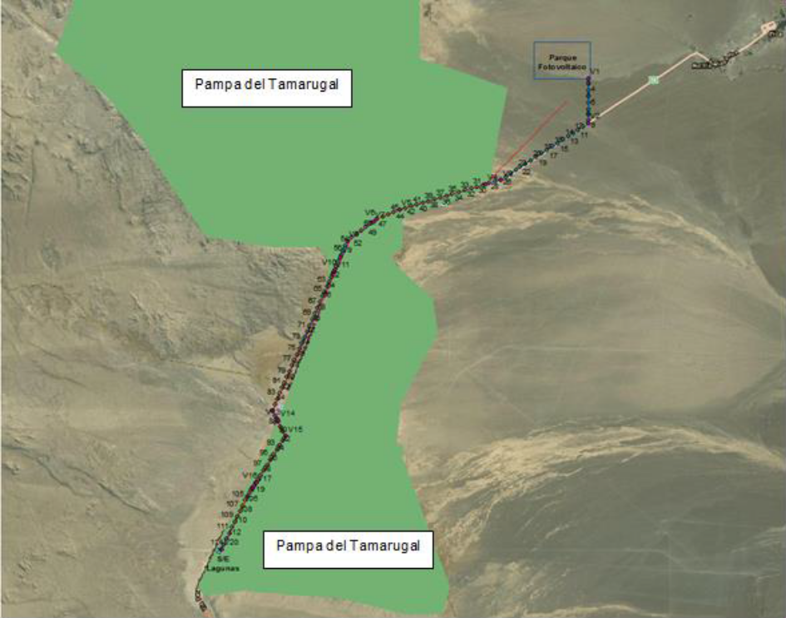
Source: Sonnedix. Environmental and Social Impact Assessment Summary.

Figure N°3. Pintados Geoglyph and separation of the Solar Pical Project ETL
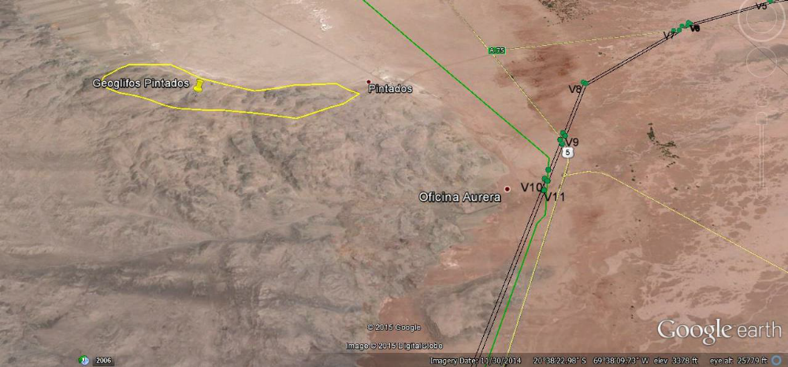
Atacama.
Source: Sonnedix. Environmental and Social Impact Assessment Summary.

(a) Physical System Characteristics and Risks (threats and vulnerabilities)
Bearing in mind that project-related works shall be carried out in far-away and inhospitable areas, devoid of any relevant infrastructure, fauna or flora, large damages to the physical and natural environment are not expected.
(b) Biotic System Characteristics and Risks (threats and vulnerabilities)
Not even the areas where the endemic species (Prosopis tamarugo) has been planted, mainly in the "Pampas de Tamarugal" Natural Reserve, which will be crossed by the transmission line, shall be impaired by this project.
Likewise, fauna, rather scarce, actually, shall not be threatened in the least by the Project activities, because although these fauna is listed on the IUCN Red List, they will not be in greater danger because of the project, largely because of construction engineering best practices in place.
The lack of water bodies, by definition, makes it impossible for water bodies in the area to be contaminated. However, to protect the soil and the potential -and so far unknown- underground water bodies, wastewater shall be treated.
Only security staff shall stay at the project site overnight, as they have been doing for some time now (providing surveillance to solar panels) since people scheduled to work at different working sites (solar panels and power transmission lines) are expected to spend the night in nearby villages and shall be moved to their workplaces on a daily basis.
Portable, chemical type washroom shall be used and their effluents shall be removed by qualified and certified companies, which will dispose of them at sites allowed, pursuant to the legislation in force. All the above shall be done in due compliance with the Project-related Waste, and Hazardous Waste Management Guidelines in place.
Due to lack of irrigation water, there is the likelihood for dust storms to be generated from excavations and vehicle movement in the site where work is being performed in the transmission line.
Finally, mention should be made of the fact that, thanks to the project, around 293.434 metric tonnes of CO2 a year would no longer be issued, thus making a positive impact on the environment. These emission savings are behind the fact that both, the Client and CAF, have reached an agreement to apply to the Green Climate Fund for co-financing funds.
(c) Socio-economic, cultural and institutional system´s characteristics and risks (threats and vulnerabilities)
The only impact on the socio-economic, cultural and institutional system shall be a positive impact, as it shall strengthen up the large Northern Chile region electrical systems, having quite small impacts on the environment.
The area known as the Pintados Petroglyph could be positively affected because of the assistance the Client could provide to the region in terms of promotion and care within the framework of the former´s Environmental and Social Plans.
When the Client was informed on the Electric Transmission Line crossing path, on the basis of which co-management alternatives between the Developer and neighbouring communities and authorities, or some other system could be looked into, the Client was very interested in getting in touch with them.

III. Environmental and Social Impact Assessment
Bearing in mind the extreme characteristics present in the Atacama Desert and the good environmental and social performance of the Client all along the early Project stages, this project, in theory and pursuant to construction engineering best practices and a proper environmental and management, shall only bring long-term positive impacts along.
Small, quite localized, and easily avoidable impacts that will arise over the works construction stage and the even fewer impacts that could arise over the photovoltaic park operation and maintenance stage are not even comparable in size and duration to benefits expected.
Indeed, except in cases of accidents or vandalism, negative impacts likely arising out of the construction of the photovoltaic plant (installation and connection of solar panels) are minimal when compared to the benefits expected to be achieved: energy input to the SING, consolidation of the interconnection between the SING and SIC systems, reduction of greenhouse gases, etc.
Notwithstanding the above, impacts showing a rather negligible potential to become into problems were identified by the Client through surveys the latter has so far conducted.
The activity most likely to generating impacts is doubtless the transmission line, since its installation shall be entailing land removal, visual impact, the likely disruption of traffic along the road nearby, impaired waterways, which regardless of their not being usual, should be prevented, etc. Bearing the dryness of the area in mind, there is still another impact on air quality in the working site, as dust clouds could be generated which, due to lack of water, would be difficult to keep in check.

(a) Impacts on the physical system
1. Generation of specific erosion processes
2. Impairment of riverbeds and flashing streams
3. Visual Impact
4. Timely impairment of air quality

(b) Project Impacts on the biotic system
1. Unnecessary deforestation of protected trees
2. Wildlife impairment
Soil contamination

(c) Project Impacts on the socioeconomic, cultural and institutional system
- . Impairment of Protected Areas ("Tamarugal Pampa" Natural Reserve)
- Impairment of the everyday life of users of the road nearby the LTE
- Impairment of the everyday life in towns near the work site: Pica, Matilla, Pozo Almonte and others

IV. Key Issues
From an environmental and social stance, critical issues are few, as listed below:
- Possible damage that may be caused to sites having a natural / equity worth (Tamarugal Pampa Natural Reserve / Pintados Petroglyph).
- Creating expectations and relevant dissatisfaction because of the belief that the project shall be hiring intensive labour from populations nearby work fronts.

V. Major environmental and social opportunities
An opportunity for the Project consolidation to be backed up through an interaction between the client and the CAF PASOS Programme, being conducted by the CAF Social Development Vice-Presidency is available. Indeed, in close parallel to the work being done by PASOS and AySA, an effort could be made to learn how to set up sustainable productive projects involving communities engaged in the operation and maintenance of a Photovoltaic Power Plant and Transmission Line, supporting job creation, strengthening up and buttressing the Cultural Heritage, or helping promote initiatives dealing with environmental and social management capacity-building endeavours at the several entities involved in the project, either through technical cooperation funds or any of the Greens Funds to which CAF and its clients have access through the DACC,
Further on, as mentioned, there is a real likelihood for funding to be granted to this project by the Green Climate Fund, as the Client has requested CAF´s assistance as a Green Climate Fund “window".

VI. Environmental and social management of the operation
The Client has not only secured the environmental permits needed to set up work at the site with a 0.5MW Pilot Plant but has also invested in a series of surveys and field campaigns designed to collect the information required to design a sort of Environmental and Social Management Plan (ESMP) in several documents.
The Client has specifically drafted up documents as follows to deal with the few impacts referred to above:
1. Environmental and Social Management System;
2. Occupational Health and Safety Plan;
3. Emergency Preparedness and Early Response Plan;
4. Traffic Management and Access Plan;
5. Waste and Hazardous Waste Management Plan;
6. Environmental Monitoring Plan;
7. Community Involvement Plan (including the Complaints Management Mechanism and the procedure for archaeological findings).
All of the above plans have been reviewed during the Assessment Mission and for drafting up this IAS; these plans have a high level of quality and adequacy to address the possible risk situations and the different impacts that may arise, and are identified, even though their occurrence may show a low probability.

(a) Preventive, mitigation and / or corrective measures
As a whole, documents listed in the previous paragraph, sometimes redundantly, contain all necessary and sufficient measures to execute a project, without the impacts being generated by the project may act against it and its environmental, social or legal feasibility.

Measures originally defined by the operation
To counter the risk being posed by the project, the Client has designed in a total of eight documents the measures to prevent, mitigate, or compensate for the likely negative impacts -and upgrading the positive impacts- the project may have.
The above was achieved on the basis of a number of specific surveys on the Project area, such as the Environmental Impact Assessment, the Wildlife and Vegetation Inventory, public consultation processes with both, government agencies and people in nearby towns, etc.
Thus, the main measures spelled out in these documents are:
1. Management of the physical system
i. Prevention of soil contamination
ii. Control of erosion generation processes
iii. Proper construction of works, mainly the towers foundations
iv. Irrigation in critical work areas to avoid large dust storms (water shall be carried to the site for further storage in tanks)
2. Management of the biotic system
i. Preservation of flora and fauna
ii. Preventing pollution of flashing streams
iii. Control in sites fostering the presence of disease vectors (sewage, or fresh water storage sites)
iv. Waste Management, including hazardous wastes (batteries, acids, etc.)
3. Socio-economic, cultural and institutional system management
i. Community communication plan
ii. Preservation and value enhancement of the archaeological and paleontological heritage
iii. Health and Safety at Work

Measures identified by CAF and additional to those originally defined by the operation
As spelled out above, a proposal has been made for works to be appropriated by stakeholders (beneficiaries, those affected and neighbours), to assess whether measures may be undertaken for people involvement within the framework of the PASOS programme being implemented by the VDS. Therefore, the experts´ team in charge of this programme should be consulted at the appropriate time, through the Environment and Climate Change Senior Executive for Chile.
Furthermore, the Green Climate Fund CAF Focal Point and the Environment and Climate Change Senior Executive for Chile are getting the operation ready for this Fund to approve a green funding line for the Project.

(b) Estimated environmental and social budget
While the Client has already invested a large amount of money in the Environmental and Social Management so far undertaken, the Client has still to submit an environmental budget of the project works.
The Client only assumes that, regardless of the cost, he / she should address the issues as they may arise vis-à-vis this matter to ensure the project viability, even the legal viability thereof, since he / she is aware of the severity of Chilean environmental authorities in case of breach of the measures which, having been submitted in the respective EIA, the Environmental Authority has required the Client to submit.
Nevertheless, and bearing in mind that the project is being drafted up for submission to the Green Climate Fund, the environmental and social budget shall be generated within a fixed time, and progress reports should be submitted as required by the Client.

VII. Environmental and Social Viability of the Project
Once the project has been evaluated, a visit has been made to the works location site, the technology to be applied is already known, and documents provided have been perused through, no problems are foreseen that may threaten the environmental and social viability of this operation. "It has been deemed that the project may be executed without incurring in significant environmental and social risks, provided that: (i) The set of environmental and social conditions as set forth by CAF in this report has been designed and properly implemented; (Ii) environmental and social legislation requirements in force and applicable law are duly abode by; and iii) measures and actions being foreseen in the environmental surveys are being implemented.
Over the evaluation phase the Project was found easy to implement and, although unlikely, impacts that could occur are negligible in intensity and impairment, together with the quality of plans the Client has already drawn up to address those impacts, allows us to ensure that the environmental and social viability of the project is real.
Environmental and Social Safeguards
Nº | Aspect | Complies with |  | Remarks
Nº | Aspect | Yes | No
i. | National legislation | X |  | Confirmation has been received that the Client has already conducted the Environmental Impact Surveys over the Pilot Stage. Only minor changes at the project site remain to be addressed through the Letter of Relevance mechanism, in abidance with the Chilean Law. Once this requirement has been fulfilled, the Project-attached environmental and social plans shall be concluded by the Client.
ii. | Assessment of environmental and social impacts, risks and opportunities | X |  | Impacts, risks and opportunities have been assessed, and measures to address them have already been included in a series of environmental and social management plans. All of these plans are subject to amendments insofar the Environmental Authority so requires in their reply to the Letter of Relevance being submitted to them by the Client.
iii. | Environmental and social Budget and management measures | X |  | Several plans have been drafted up by the Client (altogether, these plans make up a thorough Environmental and Social Management Plan) which shall be further revised once an answer to the Letter of Relevance being submitted to the Environmental Authority has been acknowledged, provided that answer so warrants.
iv. | Institutional strengthening, Human Resources capacity-building and information | X |  | The Client is a company made up by a highly-skilled professional staff who are properly trained and updated. Regular training is provided to both, the Client staff, contractors and subcontractors.
v. | Preservation of water resources | X |  | Although the area is quite dry, the Client shall be ensuring a rational use of water, including wastewater treatment over the construction phase.
vi. | Natural parks and protected natural areas | X |  | The Client has requested permission to get the transmission line to run across the "Tamarugal Pampas" Natural Reserve. The archaeological protection area around the Pintados Geoglyph shall not be disturbed by the project, even though the transmission line shall be running close to it.
vii. | Disaster risk prevention | X |  | A series of foresight activities vis-à-vis risks and natural disasters have been foreseen by the Client (one of the plans likely to making up the ESMP is the “Emergency Preparedness and Early Response” Plan.
viii. | Contamination Prevention | X |  | Prevention activities are incorporated into the Project to deal with the impact of pollution on areas surrounding the work site. These activities are mainly addressed to water resources (effluents) and soil.
ix. | Cultural Heritage in the region | X |  | Activities are included in the project to identify, and / or alert on, high archaeological or cultural value findings in the works site, as set forth in measures included in the Archaeological Plan. In like manner, the project´s Relationships with the Community Plan provides for joint actions to be undertaken to add value to the Pintados Geoglyph, located at close distance from the transmission line.
x. | Indigenous Populations and Ethnic groups and cultural diversity | X |  | The Project intends to be socially inclusive. So much so that, while the area is not an Indigenous Population area, people who identify themselves as Indigenous Population have indeed been identified and, therefore, the Relationships with the Community Plan activities shall be implemented bearing this fact in mind. Protection of cultural diversity in areas surrounding the project works is a key component of the Project.
xi. | Participation and community development | X |  | A commitment has been made by the Client to undertaking participatory activities and fora ensuring the proper inclusion of local opinion. In like manner, a Mechanism to address Grievances and Complaints has been drawn up by the Client, warranting the free and timely involvement of each and every person who so desires.
xii. | Resettlement and / or involuntary relocation | X |  | No resettlements, neither relocations are required by this Project.
xiii. | Childhood Protection | X |  | Pursuant to the Law, child labour is prohibited by the Client.
xiv. | Gender Equity | X |  | The Client is an equal-opportunity employer offering jobs depending on the specifics of the Works required
Source: Authors

The Direction of the Environment and Climate Change (DECC) does not foresee any environmental and social problems to arise, provided the project is executed pursuant to good construction engineering practices. Therefore, DECC deems the project to be environmentally and socially viable. Nevertheless, and as usual, a monitoring and follow-up of the project shall be applied according to the project´s own specificities, pursuant to the Client performance and the civil society feedback.

VIII. Loan contract -related environmental and social conditions
As mentioned, the operation is considered environmentally and socially viable, mainly because the Client has demonstrated, judging by previous surveys submitted to CAF during the evaluation phase, that the Client not only is governed by the provisions in environmental legislation in the country, but also meets CAF environmental and Social Safeguards. At CAF request, A comparative assessment was conducted by the Client of each safeguard, to find out how management fulfills its mission and is duly aware that the project is intended to be in place over a long time, and the project neighbours could be the best allies.
Notwithstanding the foregoing, the Client should abide by CAF Environmental and Social Safeguards, which the Client declares to be duly aware of, by Chilean environmental regulations in force, and the Special Environmental and Social Conditions as follows:
Before the start of each work:
- The Environmental Authorization pursuant to current legislation (Environmental Certification Resolution (ECR); Environmental Impact Statement (EIS); Relevance Charter, etc.)
Over the disbursement period:
Submitting to CAF satisfaction:
- The Environmental and Social Management Plan (ESMP), with times adjusted to the actual times of the works, including at least the following components: Budget, Community Communication Plan, Signalling Plan on Work sites, Contingencies Attention Plan and specific archaeological matters-addressed measures, health and safety at work, and any other matter as approved for the project. This Plan shall be submitted no later than forty-five (45) days after the first disbursement has been granted.
- The environmental surveys and authorizations for any new work requiring them, or an underwritten report showing that such authorization is not required.
- Quarterly progress reports (January-March; April-June; July-September; and October - December) spelling out the physical and financial progress (budget execution) of environmental and social aspects of the Project. No later than thirty (30) days have elapsed after the quarter in question.
- Special Reports every time that CAF performs follow-up inspections, and at any time at CAF request, with the scope and formats as required in due course by CAF.
- Closing Report: once the project execution is over, but no later than one hundred and twenty (120) days following the date of the last disbursement, and within terms being laid out by CAF.
- Whenever there is any significant change in the characteristics of the project or the natural or social setting in which the project is to be executed, likely generating new environmental and social impacts not foreseen in the assessment previously conducted by CAF, or likely maximising existing impacts, these changes should be informed to CAF for the latter´s prior assessment and compliance.
- Specifically, in case an additional activity or project is implemented within the "Pampa aquifers" Natural Reserve, Safeguard VI stating that "...pursuant to the relevant legislation in the country where this operation is being carried out, projects in protected areas are funded to the extent that the operation will contribute to meeting the objectives for which the protected area in question has been created ... " shall be activated as a precautionary principle.

If approved, the loan being applied for shall fund the construction of solar panels to generating 142,5MW, thus reaching the 143MW authorised for transmission.

